**Advanced Computer Networks**

**Project Report**

**Name - Rahul Deepak Prabhu**

**NET ID - rdp130130**

**Name - ShubhankarVenkatesh**

**NET ID - sxv148130**

**Problem Statement: Chat Program:Design and program (socket programming) a simple chat session application. Design a session between two individuals on separate computers to exchange messages. (An extended version of this project, which include graphical interface, may be a 2-person project).**

**For Extra Credit - We have implemented multi-user chat session as well as Android Application for Cross Platform Chat session, i.e. between PCs and Android Phones. We have also implemented the chat session with time stamps for each message.**

**Introduction:**

Our objective was to create a chat session between two or more individuals in a graphical interface from different machines. The chat session was to be based on socket programming. We used Java language to implement the graphical chat session based on socket programming. Considering there are a number of graphical modules are present in Java which can be easily modified to our own requirement. Hence we had more inclination of implementing the chat session in Java. To add more flexibility of adding any number of users to this session we decided to setup a server of our own using Amazon AWS Cloud. With this step we were able to add any number of users in the chat session. The user would just have to run the client program, enter the server IP address and start their chat sessions after entering their screen name to be displayed for identification. When the client is registered with a unique name, then the user can begin their chat sessions and their messages will be broadcast to all the active users. We have also implemented Android Application for the Chat Program, thus we were able to integrate the chat program onto PC as well as Android Phones

**Problem Breakdown:**

**Chat Server:**

1. To make chat session using socket programming, we used the "Socket" class of java to implement a TCP socket connection between the Chat Server and the Chat Client.
2. The java server was kept in infinite loop to keep listening to the Port "9001" for any incoming connection.
3. Since the problem of chat session was to implement chat session on 3 or more different machines, hence uniqueness of user logins was thought of. Hence we build in an exception handler to discard any request for chat login with repeated name.
4. After the user has been accepted, the server would read the input stream and broadcast it to all the currently active clients. *The previous chat conversations will be unavailable*.

**Chat Client:**

1. For GUI interface of Chat Windows, we used Java Swing class to implement chat window boxes.
2. To start chat session the user would be required to enter the IP address of the server and server would request for Screen Name to be used for Chat Session.
3. To implement uniqueness of client, the chat server would run exception handler until the user enters a unique screen name.The chat window will be enabled only when the screen name of the user is accepted by the server.
4. After user is accepted, the stream reader will read the text entered by the user and it will be broadcast to all other chat clients along with the timestamp.

**Block Diagram**

Amazon AWS Cloud Server

Java Chat Server

Android Chat Program

Java Chat Client n

Java Chat Client1

**Problems Faced:** We had many problems that we faced when we were implementing the client server:

* We did not have all the libraries required as we had an older version of eclipse(IDE for java)
* With the android app we could not run the app on the phone but it worked on the emulator. We had to initialize a new UI thread every time we had to play with the ui.
* 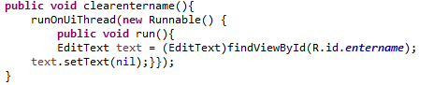
* Permissions for the internet was not enabled by default for the app and we had to enable it through the manifest file for the app
* 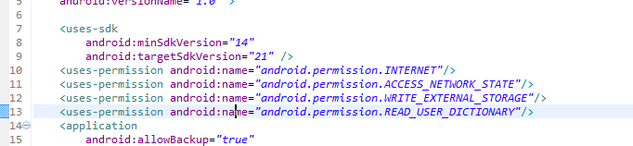
* Debugging android at runtime is very tedious as we had to go through the logcat at every instance of time
* We encountered many other problems but we could clear them through many online forums.
* We have all the code on github for further development.

**Conclusion:**

The multi-user chat session was successfully implemented using Java programming language in a graphical interface with user on 3 or more machines, as well as Android N-Way Chat Session Application. Overall we were able to develop a Multi-user cross platform chat messenger for the project.

**Screen Shots**

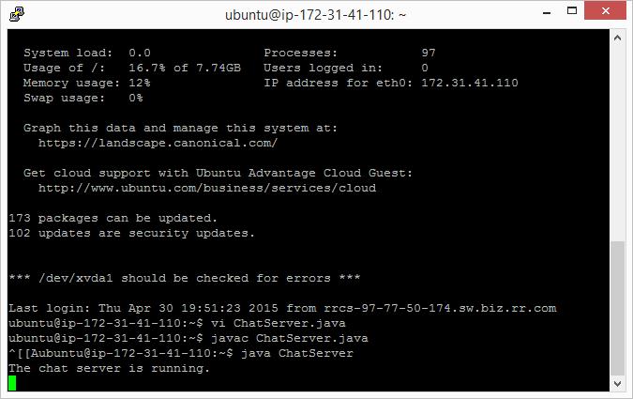

**Fig 1 - Chat Server Running on Amazon EC2 Server with IP address**

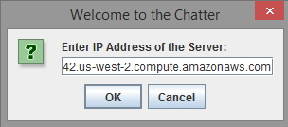

**Fig 2 - Chat User Entering Chat Server IP Address**

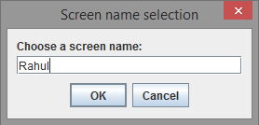

**Fig 3 - Entering Screen Name of Chat User for Identification**

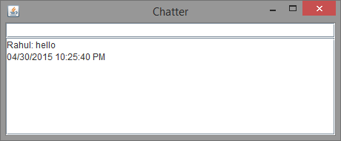

**Fig 4 - Chat Messages Along with Timestamp**

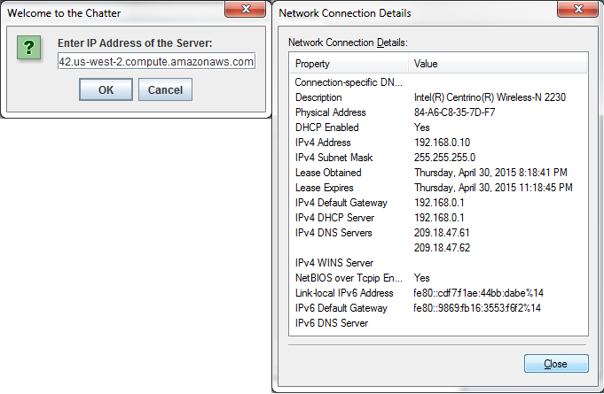

**Fig 5 - User 2 Entering Logging Onto Chat Session with Different IP**

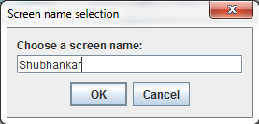

**Fig 6 - User 2 Entering Name for Starting Chat Session**

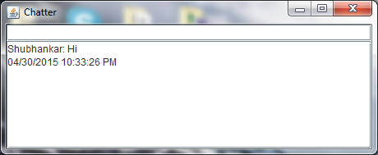

**Fig 7 - User 2's Chat Message Window**

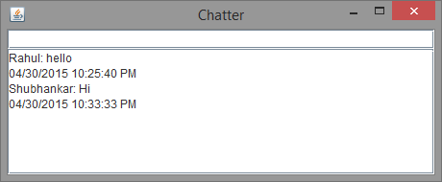

**Fig 8 - User 1's Chat Message Window after 2nd User Messaging**

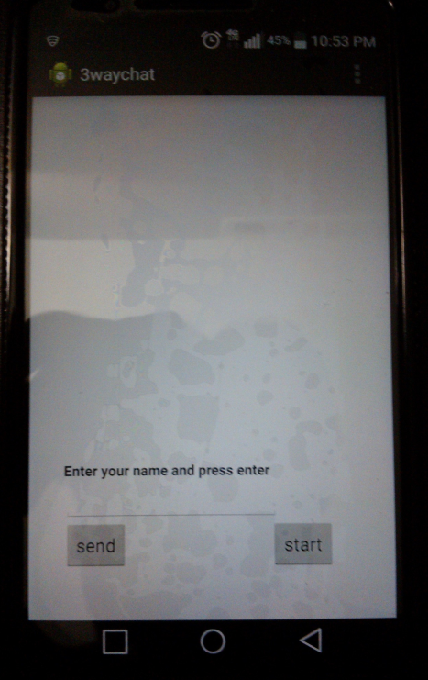

**Fig 9 - Opening Chat Session on Android**

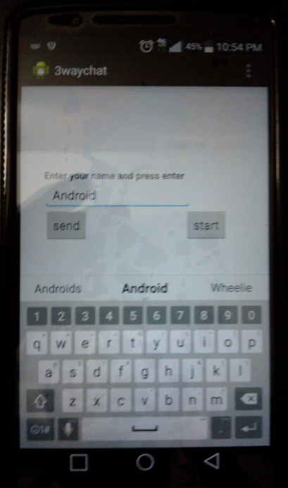

**Fig 10 - Entering Username in Android Chat Session**

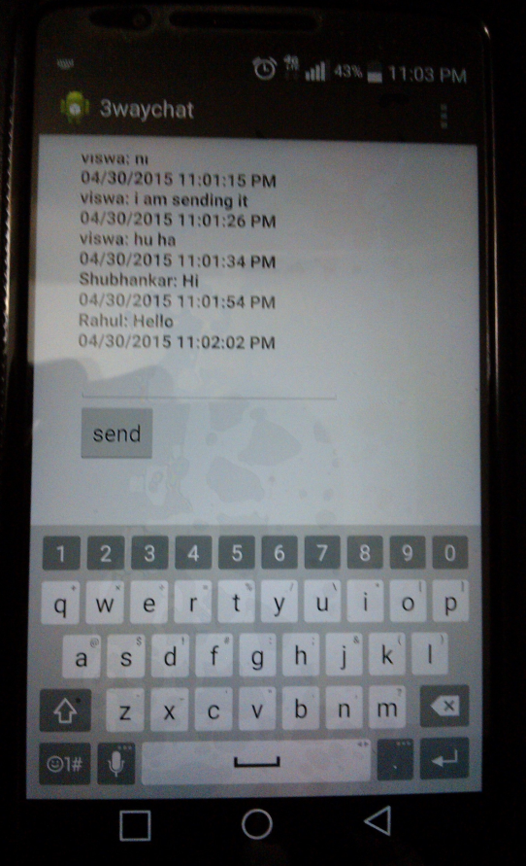

**Fig 11 - Chat Messages in Android Chat Window**

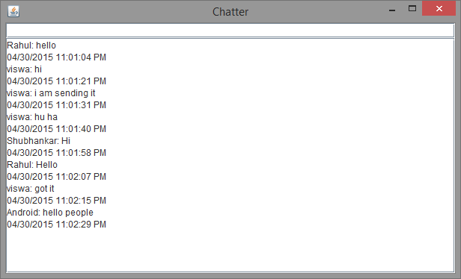

**Fig 12 - Mixed Chat Session from Android and PC**

**Java Code :**

**Java Code for Chat Server:**

**package** server;

**import**java.io.BufferedReader;

**import**java.io.IOException;

**import**java.io.InputStreamReader;

**import**java.io.PrintWriter;

**import**java.net.ServerSocket;

**import**java.net.Socket;

**import**java.util.HashSet;

**publicclass**ChatServer {

**privatestaticfinalint*PORT*** = 9001;

**privatestatic**HashSet<String>*names* = **new**HashSet<String>();

//hash table of all names

**privatestatic**HashSet<PrintWriter>*messages* = **new**HashSet<PrintWriter>();

//hash table of all messages

**publicstaticvoid** main(String[] args) **throws** Exception {

System.***out***.println("The chat server is running.");

ServerSocketlistener = **new**ServerSocket(***PORT***);

**try** {

**while** (**true**) {

**new** Handler(listener.accept()).start();

}

} **finally** {

listener.close();

}

}

**privatestaticclass** Handler **extends** Thread {

**private** String name;

**private** Socket socket;

**private**BufferedReaderin;

**private**PrintWriterout;

**public** Handler(Socket socket) {

**this**.socket = socket;

}

**publicvoid** run() {

**try** {

// Create character streams for the socket.

in = **new**BufferedReader(**new**InputStreamReader(

socket.getInputStream()));

out = **new**PrintWriter(socket.getOutputStream(), **true**);

**while** (**true**) {

out.println("SUBMITNAME");

name = in.readLine();

**if** (name == **null**) {

**return**;

}

**synchronized** (*names*) {

**if** (!*names*.contains(name)) {

*names*.add(name);

**break**;

}

}

}

out.println("NAMEACCEPTED");

*messages*.add(out);

**while** (**true**) {

String input = in.readLine();//read input from the stream of the socket

**if** (input == **null**) {

**return**;

}

**for** (PrintWriterwriter : *messages*) {//send out the message to other users with "message" appended at the beginning

writer.println("MESSAGE " + name + ": " + input);

}

}

} **catch** (IOExceptione) {

System.***out***.println(e);

} **finally** {

**if** (name != **null**) {

*names*.remove(name);

}

**if** (out != **null**) {

*messages*.remove(out);

}

**try** {

socket.close();

} **catch** (IOExceptione) {

}

}

}

}}

**Java Code for Client:**

**package**lastchance;

**import**java.awt.event.ActionEvent;

**import**java.awt.event.ActionListener;

**import**java.io.BufferedReader;

**import**java.io.IOException;

**import**java.io.InputStreamReader;

**import**java.io.PrintWriter;

**import**java.net.Socket;

**import**java.text.SimpleDateFormat;

**import**java.util.Date;

**import**javax.swing.JFrame;

**import**javax.swing.JOptionPane;

**import**javax.swing.JScrollPane;

**import**javax.swing.JTextArea;

**import**javax.swing.JTextField;

**publicclass** last {

BufferedReaderin;

PrintWriterout;

JFrameframe = **new**JFrame("Chatter");

JTextFieldtextField = **new**JTextField(40);

JTextAreamessageArea = **new**JTextArea(20, 60);

**public** last() {

// Layout GUI

textField.setEditable(**false**);

messageArea.setEditable(**false**);

frame.getContentPane().add(textField, "North");

frame.getContentPane().add(**new**JScrollPane(messageArea), "Center");

frame.pack();

// Add Listeners

textField.addActionListener(**new**ActionListener() {

**publicvoid**actionPerformed(ActionEvente) {

out.println(textField.getText());

textField.setText("");

}

});

}

**private** String getServerAddress() {

**return**JOptionPane.*showInputDialog*(

frame,

"Enter IP Address of the Server:",

"Welcome to the Chat applicstion",

JOptionPane.***QUESTION_MESSAGE***);

}

**private** String getName() {

**return**JOptionPane.*showInputDialog*(

frame,

"enter your name:",

"Screen name selection",

JOptionPane.***PLAIN_MESSAGE***);

}

**privatevoid** run() **throws**IOException {

// open the socket

String serverAddress = getServerAddress();

Socket socket = **new**Socket(serverAddress, 9001);

in = **new**BufferedReader(**new**InputStreamReader(

socket.getInputStream()));

out = **new**PrintWriter(socket.getOutputStream(), **true**);

// Process all messages from server, according to the protocol.

**while** (**true**) {

String line = in.readLine();

**if** (line.startsWith("SUBMITNAME")) {

out.println(getName());

} **elseif** (line.startsWith("NAMEACCEPTED")) {

textField.setEditable(**true**);

} **elseif** (line.startsWith("MESSAGE")) {

messageArea.append(line.substring(8) + "\n");

Date date = **new**Date();

SimpleDateFormatsdf = **new**SimpleDateFormat("MM/dd/yyyy h:mm:ss a");

String formattedDate = sdf.format(date);

System.***out***.println(formattedDate);

messageArea.append(formattedDate+"\n");

//time stamp

}

}

}

**publicstaticvoid** main(String[] args) **throws** Exception {

lastclient = **new** last();

client.frame.setDefaultCloseOperation(JFrame.***EXIT_ON_CLOSE***);

client.frame.setVisible(**true**);

client.run();

}

}

**Code For Android App:**

**package**com.example.waychat;

**import**android.app.Activity;

**import**android.os.Bundle;

**import**android.view.Menu;

**import**android.view.MenuItem;

**import**java.io.IOException;

**import**java.io.PrintWriter;

**import**java.net.Socket;

**import** java.io.*;

**import** java.net.*;

**import**java.text.SimpleDateFormat;

**import**java.util.Date;

**import**android.view.View;

**import**android.widget.Button;

**import**android.widget.EditText;

**import**android.widget.TextView;

**publicclass**MainActivity**extends** Activity {

**int**bytesRead=0;

PrintWriterout;

String nil=**null**;

**publicvoid**clearentername(){

runOnUiThread(**new** Runnable() {

**publicvoid** run(){

EditTexttext = (EditText)findViewById(R.id.***entername***);

text.setText(nil);}});

}

@Override

**protectedvoid**onCreate(Bundle savedInstanceState) {

**super**.onCreate(savedInstanceState);

setContentView(R.layout.***activity_main***);

Button send=(Button) findViewById(R.id.***send***);

send.setOnClickListener(**new**View.OnClickListener(){

**publicvoid**onClick(View arg0){

EditTexttext = (EditText)findViewById(R.id.***entername***);

String convtext = text.getText().toString();

out.println(convtext);

//text.setText(nil);

clearentername();

}

});

//String convtext = text.getText().toString();

Button start=(Button) findViewById(R.id.***start***);

start.setOnClickListener(**new**View.OnClickListener() {

**publicvoid**onClick(View v) {

Button button = (Button) v;

button.setVisibility(View.***GONE***);

Thread cThread = **new**Thread(**new**ClientThread());

cThread.start();

}

**finalclass**ClientThread**implements** Runnable{

**publicvoid**viewmessage(**final** String printthis){runOnUiThread(**new** Runnable() {

@Override

**publicvoid** run() {TextViewtext1 = (TextView) findViewById(R.id.***text1***);

text1.append(printthis);

//EditText text8 = (EditText)findViewById(R.id.entername);

//text8.setText(nil);

//stuff that updates ui

}

});

}

**publicvoid** run(){

EditTexttext7 = (EditText)findViewById(R.id.***entername***);

String convtext = text7.getText().toString();

clearentername();

//text_vi text = (EditText)findViewById(R.id.entername);

/*TextView text1 = (TextView) findViewById(R.id.text1);

text1.setText(convtext);*/

Socket sock1;

**try**{

sock1 = **new**Socket("ec2-54-68-62-42.us-west-2.compute.amazonaws.com", 9001);

viewmessage("Waiting...");

viewmessage("Accepted connection : " + sock1);

//counter++;

// receive file

// InputStream is = sock1.getInputStream();

BufferedReaderin = **new**BufferedReader(**new**InputStreamReader(sock1.getInputStream()));

//BufferedReaderbr = new BufferedReader(i);

//intbuffsize = sock1.getReceiveBufferSize();

//byte [] mybytearray = new byte [buffsize];

//FileOutputStreamfos = new FileOutputStream(Environment.getExternalStorageDirectory().getAbsolutePath()+"/Download/recieved1.jpg"); // destination path and name of file

out = **new**PrintWriter(sock1.getOutputStream(), **true**);

**while** (**true**) {

String line = in.readLine();

**if** (line.startsWith("SUBMITNAME")) {

viewmessage(convtext);

out.println(convtext);

clearentername();

} **elseif** (line.startsWith("NAMEACCEPTED")) {

**continue**;

} **elseif** (line.startsWith("MESSAGE")) {

viewmessage(line.substring(8) + "\n");

Date date = **new**Date();

SimpleDateFormatsdf = **new**SimpleDateFormat("MM/dd/yyyy h:mm:ss a");

String formattedDate = sdf.format(date);

System.***out***.println(formattedDate);

viewmessage(formattedDate+"\n");

}

}

//out.flush();

// out.close();

// sock1.close();

}

**catch** (UnknownHostExceptione) {

// **TODO** Auto-generated catch block

e.printStackTrace();

} **catch** (IOExceptione) {

// **TODO** Auto-generated catch block

e.printStackTrace();

}

// **TODO** Auto-generated method stub

}

}});

}

@Override

**publicboolean**onCreateOptionsMenu(Menu menu) {

getMenuInflater().inflate(R.menu.***main***, menu);

**returntrue**;

}

@Override

**publicboolean**onOptionsItemSelected(MenuItemitem) {

**int**id = item.getItemId();

**if** (id == R.id.***action_settings***) {

**returntrue**;

}

**returnsuper**.onOptionsItemSelected(item);

}

}

**XML File for the Android App:**

<RelativeLayoutxmlns:android=*"http://schemas.android.com/apk/res/android"*

xmlns:tools=*"http://schemas.android.com/tools"*

android:layout_width=*"match_parent"*

android:layout_height=*"match_parent"*

android:gravity=*"left"*

android:paddingBottom=*"@dimen/activity_vertical_margin"*

android:paddingLeft=*"@dimen/activity_horizontal_margin"*

android:paddingRight=*"@dimen/activity_horizontal_margin"*

android:paddingTop=*"@dimen/activity_vertical_margin"*

tools:context=*"com.example.waychat.MainActivity"*>

<ScrollView

android:layout_width=*"fill_parent"*

android:layout_height=*"0dip"*

android:layout_weight=*"1"*>

</ScrollView>

<TextView

android:id=*"@+id/text1"*

android:layout_width=*"wrap_content"*

android:layout_height=*"wrap_content"*

android:layout_above=*"@+id/entername"*

android:layout_alignLeft=*"@+id/entername"*

android:text=*"@string/hello_world"*

android:textIsSelectable=*"true"*

android:textStyle=*"bold"*/>

<Button

android:id=*"@+id/start"*

android:layout_width=*"wrap_content"*

android:layout_height=*"wrap_content"*

android:layout_alignBaseline=*"@+id/send"*

android:layout_alignBottom=*"@+id/send"*

android:layout_toRightOf=*"@+id/text1"*

android:text=*"start"*/>

<Button

android:id=*"@+id/send"*

android:layout_width=*"wrap_content"*

android:layout_height=*"wrap_content"*

android:layout_alignLeft=*"@+id/entername"*

android:layout_alignParentBottom=*"true"*

android:layout_marginBottom=*"33dp"*

android:text=*"send"*/>

<EditText

android:id=*"@+id/entername"*

android:layout_width=*"wrap_content"*

android:layout_height=*"wrap_content"*

android:layout_above=*"@+id/send"*

android:layout_alignParentLeft=*"true"*

android:layout_marginLeft=*"18dp"*

android:ems=*"10"*/>

</RelativeLayout>